To install Printers:
- Click on the folder icon on your taskbar. 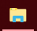
- Click on This PC on the Left hand side of your computer. 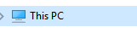
- Click on Printers. 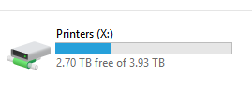
- Click on Sam Houston.
- Click on each of the bottom two printers to install them.
- Make sure and authenticate them both.

